Question
Execute the command cat names.txt| grep “Alice Using an anonymous pipe and understand how data flows between the cat and grep processes

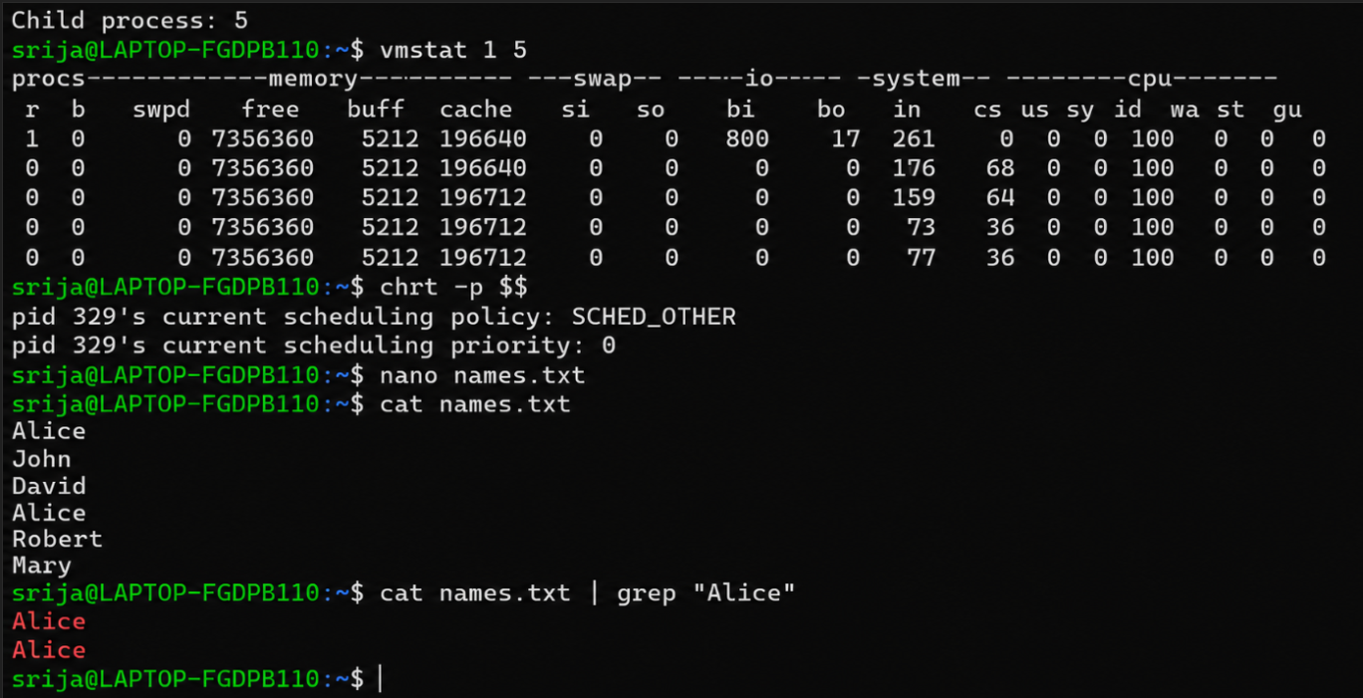
Short Theory
An anonymous pipe is used for communication between processes.In this command, cat reads the contents of names.text and sends its output through the pipe |.The grep command receives this output and displays only the lines containing “Alice”.

